Deploying the Web Tier (Presentation Layer)
- Launch Phase: Provision an EC2 instance (Ubuntu Server) within the Public Subnets.
- Server Configuration Execution:
- sudo apt update -y
- sudo apt install nginx -y
- sudo systemctl enable nginx
- sudo systemctl start nginx
- sudo systemctl status nginx
- Active: active (running)
- Output:
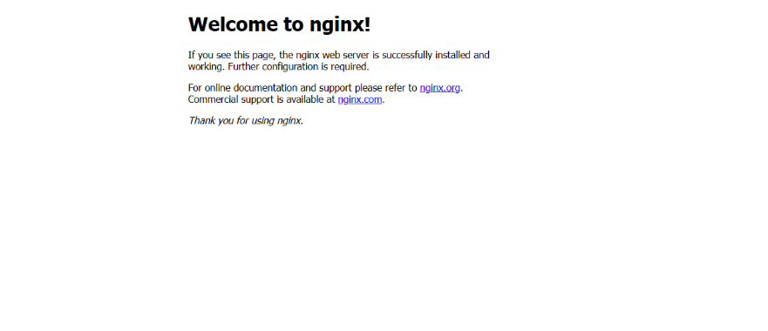
Let’s create HTML page in /var/www/html/. Create index.html file in this location. *This is the default path, but we have to do this in /usr/share/nginx/html/. Path. (index.html)
Also complete task 8
Task 8 - Configure Nginx Reverse Proxy for API Routing
Nginx Reverse Proxy API Routing path is /etc/nginx/nginx.conf
Replace nginx.conf file contain details with frontend API details.
sudo nginx -t
output
nginx: the configuration file /etc/nginx/nginx.conf syntax is ok
nginx: configuration file /etc/nginx/nginx.conf test is successful
sudo systemctl restart nginx
sudo systemctl status nginx
Output
Active: active (running)
*proxy_pass http://internal-private-Loadbalancer-DNS/; # Replace your Internal Loadbalancer DNS here*

